Addressing Class Imbalance in Machine Learning:
A Review of Oversampling and Undersampling Techniques
Faculty of Artificial Intelligence — Menoufia University
Data Science Fundamentals | 2025–2026
Abstract
Class imbalance is a pervasive challenge in machine learning classification tasks in which one class (the minority) is significantly underrepresented relative to another (the majority). This skewed distribution causes supervised learning algorithms to develop strong bias toward the majority class, yielding inflated accuracy scores yet failing to detect the rarer, often more critical, class instances. This paper provides a comprehensive, mathematically grounded review of the problem and its practical solutions. We detail classical and advanced resampling methods — including Random Oversampling, SMOTE, Borderline-SMOTE, ADASYN for oversampling, and Random Undersampling, Tomek Links, NearMiss, and Edited Nearest Neighbors (ENN) for undersampling — alongside their mathematical foundations, algorithmic descriptions, and comparative strengths and weaknesses. Specialized evaluation metrics appropriate for imbalanced settings (F1-score, ROC-AUC, G-Mean, MCC) are reviewed. Empirical evidence suggests that hybrid approaches (e.g., SMOTE + Tomek Links) frequently yield the best results. Future research directions include GAN-based oversampling, cost-sensitive ensemble methods, and streaming imbalance.

1. Introduction
Classification in supervised machine learning requires assigning an input instance x to one of C discrete class labels. Algorithms such as decision trees, support vector machines (SVMs), and neural networks learn decision boundaries by minimizing some empirical loss over a labeled training set. Their implicit assumption is that each class occupies a roughly comparable fraction of the training data.
In many real-world domains this assumption breaks down dramatically. Fraud detection, medical diagnosis, fault detection, and cybersecurity intrusion detection all exhibit highly skewed class distributions, where the event of interest — the minority class — may represent fewer than 1% of all instances. Under such conditions, a naive classifier that always predicts the majority label achieves near-perfect accuracy while contributing no practical value.
The Imbalance Ratio (IR) quantifies this skew:
IR = n_maj / n_min
where n_maj and n_min are the counts of majority and minority instances, respectively. An IR above 10 is generally considered severe; ratios of 100:1 or higher are common in fraud and medical imaging tasks.
This paper systematically surveys the most important algorithmic approaches for mitigating class imbalance through data-level resampling. We cover both oversampling strategies (which artificially increase minority representation) and undersampling strategies (which reduce majority dominance), as well as hybrid combinations. Section 2 covers background and related work; Sections 3 and 4 present mathematical formulations of key methods; Section 5 compares approaches; Section 6 reviews evaluation metrics; and Section 7 concludes with future directions.

2. Background and Related Work
Early treatments of imbalanced data focused on cost-sensitive learning — assigning higher misclassification penalties to the minority class. Resampling-based approaches emerged as a complementary paradigm, gaining widespread adoption after the publication of SMOTE.
SMOTE (2002): Chawla et al. introduced the Synthetic Minority Over-sampling Technique, which creates interpolated minority samples rather than merely duplicating existing ones. This cornerstone work has accumulated over 25,000 citations and spawned dozens of variants.
Borderline-SMOTE (2005): Han et al. restricted synthetic generation to borderline minority instances — those near the class boundary — yielding improved decision boundary quality.
ADASYN (2008): He et al. proposed Adaptive Synthetic Sampling, which weights synthetic generation proportionally to local difficulty, focusing effort on harder-to-learn regions.
Undersampling (1972–1976): Wilson's Edited Nearest Neighbors (ENN) and Tomek's modification of the Condensed Nearest Neighbor rule both focus on cleaning noisy or overlapping majority samples.
Recent comprehensive reviews (Rezvani & Wang, 2023; Yang et al., 2024) confirm that no single method dominates across all settings, and that hybrid strategies combining oversampling and undersampling consistently produce competitive results.

3. Problem Formulation
Let D = {(x_i, y_i)}_{i=1}^{n} be a binary classification dataset where y_i ∈ {0, 1} (0 = majority, 1 = minority) and n_maj + n_min = n. The class imbalance problem arises when:
n_maj >> n_min ⟹ IR >> 1
Standard accuracy is misleading under imbalance because a trivial classifier predicting all majority instances achieves:
Accuracy_trivial = n_maj / n = IR / (IR + 1)
For IR = 99 this trivial classifier achieves 99% accuracy while detecting zero minority instances. This demonstrates why accuracy alone is an insufficient performance measure.
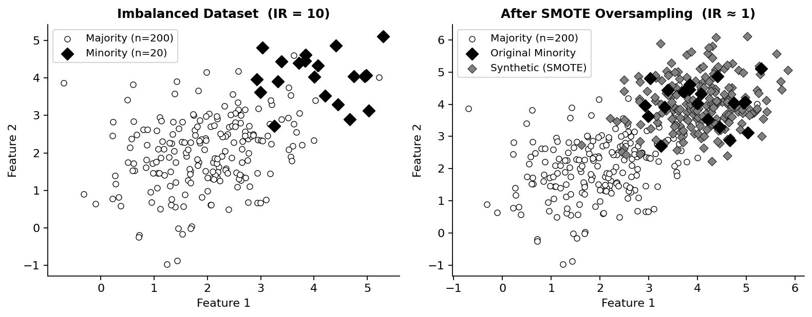
Figure 1. Illustration of class imbalance (left) and the effect of SMOTE oversampling (right). Minority instances (filled diamonds) are outnumbered 10:1 by majority instances (open circles). After SMOTE, synthetic minority samples (gray diamonds) balance the distribution.

4. Oversampling Techniques
Oversampling methods increase the size of the minority class to produce a more balanced training set, without discarding any majority data.

4.1 Random Oversampling
The simplest approach: minority instances are sampled with replacement and duplicated until n'_min ≈ n_maj. While effective for moderate imbalance, exact duplication increases overfitting risk because the model encounters no new information about the minority manifold.

4.2 SMOTE
SMOTE (Chawla et al., 2002) generates synthetic samples by linear interpolation in feature space. For each minority instance x_i, the algorithm:
- Finds its k nearest minority-class neighbors using Euclidean distance.
- Selects one neighbor x_nn uniformly at random.
- Creates a new sample: x_new = x_i + u · (x_nn − x_i), u ~ U[0,1]
This fills the minority feature manifold without exact duplication. The oversampling factor N controls how many synthetic samples are generated per original instance.
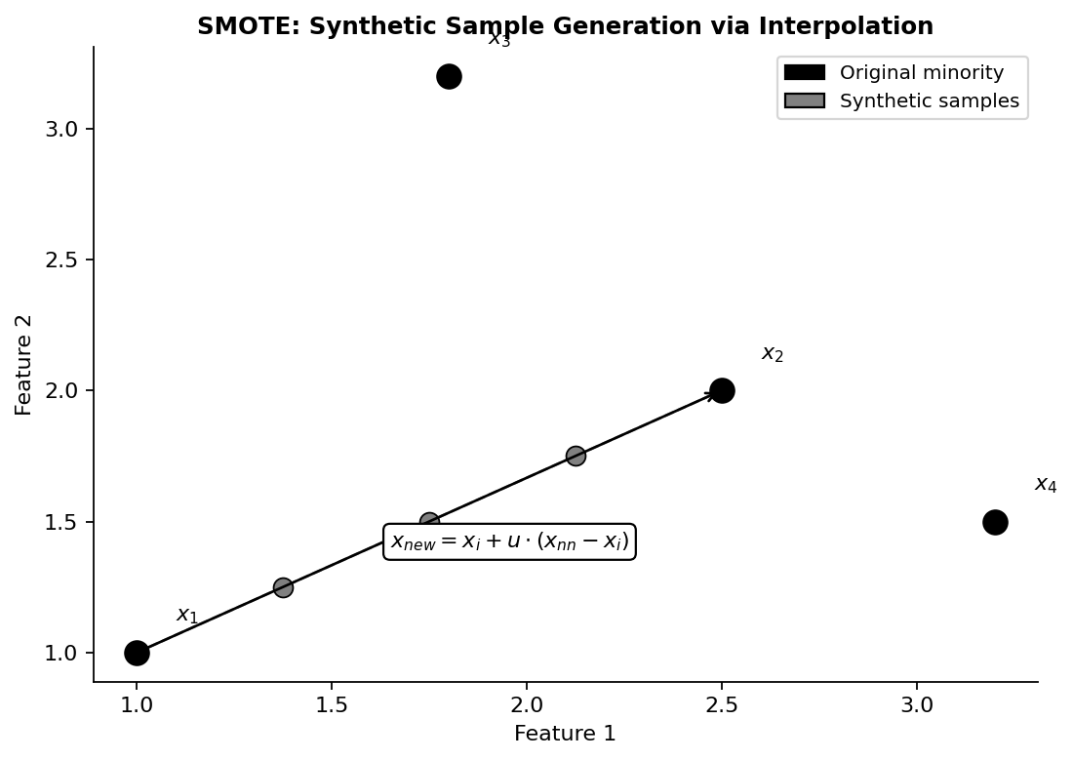
Figure 2. SMOTE synthetic sample generation. New instances (gray) are created by interpolating between original minority instances (black) along the dashed vector, using a random factor u ~ U[0,1].

4.3 Borderline-SMOTE
A variant that restricts generation to "danger zone" minority instances — those whose k-neighborhood contains roughly half majority and half minority neighbors. Three categories are defined:
- Safe: Most neighbors are minority → no synthetic generation needed.
- Danger: Roughly half minority, half majority → generate here.
- Noise: Most neighbors are majority → exclude from generation.
By focusing on the decision boundary, Borderline-SMOTE strengthens classifier discrimination in the most ambiguous feature regions.

4.4 ADASYN (Adaptive Synthetic Sampling)
ADASYN (He et al., 2008) adaptively generates more samples for minority instances that are harder to learn, defined by a higher proportion of majority neighbors. For each minority instance x_i:
r_i = Δ_i / k, Δ_i = number of majority neighbors in k-NN
Normalized probabilities r̂_i = r_i / Σ r_i determine the number of synthetic samples: g_i = r̂_i × G, where G is the total synthetic samples needed. SMOTE-style interpolation is then applied.
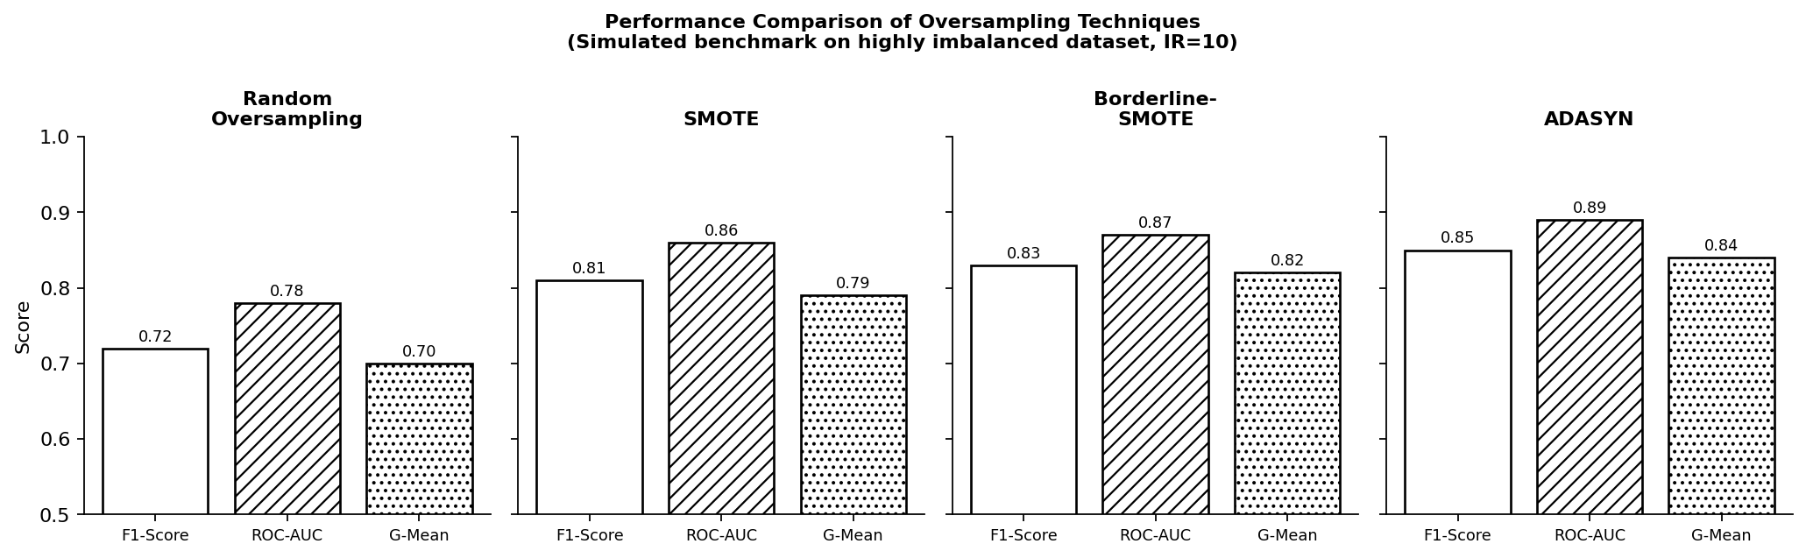
Figure 3. Performance comparison of oversampling techniques across F1-Score, ROC-AUC, and G-Mean on a simulated highly imbalanced dataset (IR = 10). Adaptive methods (Borderline-SMOTE, ADASYN) consistently outperform basic approaches.

5. Undersampling Techniques
Undersampling methods reduce the majority class to achieve balance. They risk losing potentially informative majority instances but reduce training time and model complexity.

5.1 Random Undersampling
Randomly removes majority instances (with or without replacement) until n'_maj ≈ n_min. Fast and simple, but statistically risky: discarded instances may carry important distributional information, increasing classifier variance.

5.2 Tomek Links
A Tomek link exists between a majority instance x_i and a minority instance x_j (of different classes) if and only if no other point x_k is closer to either:
∀ x_k: d(x_i, x_j) ≤ d(x_i, x_k) AND d(x_i, x_j) ≤ d(x_j, x_k)
Removing the majority instance in each Tomek link cleans overlapping or noisy boundary regions. It is frequently applied as a post-processing step after SMOTE to further refine the decision boundary (SMOTE-Tomek).
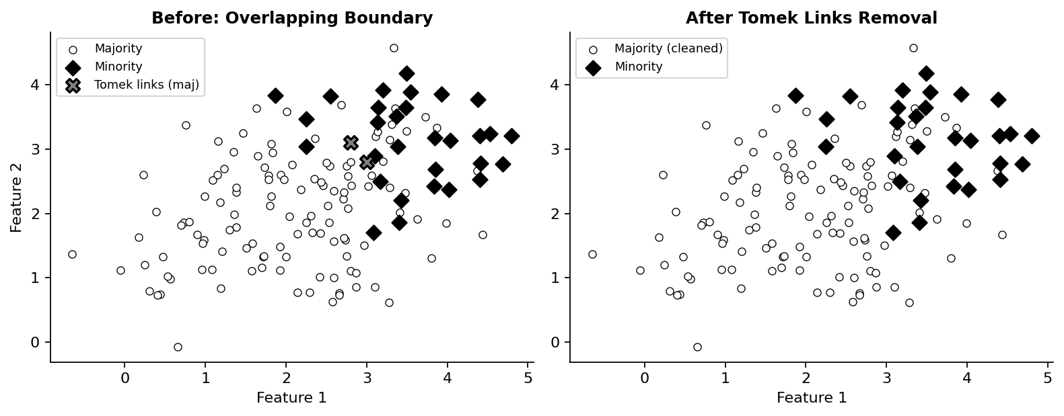
Figure 4. Effect of Tomek Links removal. Overlapping majority instances (marked X) near the minority cluster are identified as Tomek links and removed (right), resulting in a cleaner decision boundary.

5.3 NearMiss
NearMiss selects majority instances based on their proximity to the minority class. Three variants differ in their selection criterion:
- NearMiss-1: Select majority samples with smallest average distance to their 3 nearest minority neighbors.
- NearMiss-2: Select majority samples with smallest average distance to all minority instances.
- NearMiss-3: For each minority instance, retain the m majority samples closest to it (per minority instance).

5.4 Edited Nearest Neighbors (ENN)
ENN (Wilson, 1972) cleans noisy samples using the k-NN rule. For every instance x_i, examine its k nearest neighbors: if the majority class among neighbors differs from x_i's own class, remove x_i. Applied to majority instances, ENN primarily removes majority noise near the minority boundary.

6. Comparison: Oversampling vs. Undersampling

Technique | Type | Info Loss | Overfit Risk | Best Use Case
Random Oversampling | Over | None | High | Small datasets, quick baseline
SMOTE | Over | None | Moderate | General purpose, tabular data
Borderline-SMOTE | Over | None | Low | Overlapping class boundaries
ADASYN | Over | None | Low | Hard-to-learn regions
Random Undersampling | Under | High | Low | Very large datasets
Tomek Links | Under | Low | Low | Cleaning noisy boundaries
NearMiss | Under | Moderate | Low | Large datasets, speed priority
ENN | Under | Low | Very Low | Noise removal, preprocessing
SMOTE + Tomek | Hybrid | Minimal | Low | General; moderate imbalance
SMOTE + ENN | Hybrid | Minimal | Low | Extreme imbalance cases

Practical guidance: Use oversampling (SMOTE or ADASYN) when the dataset is small or minority preservation is critical. Prefer undersampling when training speed matters and the majority class contains substantial noise. Hybrid methods (SMOTE + Tomek Links; SMOTE + ENN) combine the strengths of both paradigms and are recommended as the default strategy for most imbalanced classification problems.

7. Evaluation Metrics for Imbalanced Classification
Standard accuracy is entirely inadequate for imbalanced settings. The confusion matrix provides the foundation for appropriate metrics:
| TP FP | | FN TN |

Metric | Formula | When to Use
Precision | TP / (TP + FP) | Cost of false positives is high
Recall | TP / (TP + FN) | Missing minority instances is costly
F1-Score | 2 × (Precision × Recall) / (Precision + Recall) | Balanced precision-recall tradeoff
ROC-AUC | Area under TPR vs FPR curve | Ranking ability; threshold-independent
G-Mean | √(Recall × Specificity) | Balancing both classes equally
MCC | (TP·TN − FP·FN) / √((TP+FP)(TP+FN)(TN+FP)(TN+FN)) | Overall binary classification quality

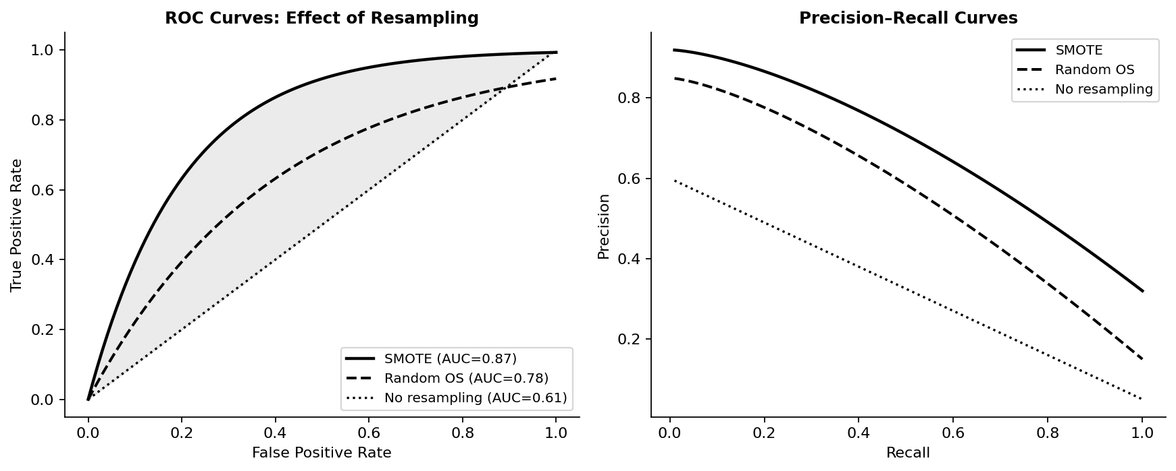
Figure 5. ROC curves (left) and Precision-Recall curves (right) comparing no resampling, Random Oversampling, and SMOTE. SMOTE consistently achieves superior ROC-AUC and precision-recall trade-off. Note: PR curves are generally more informative than ROC curves under severe imbalance.
Key recommendation: Always report F1-Score and ROC-AUC together. For extreme imbalance (IR > 50), also report G-Mean and the Precision-Recall AUC (PR-AUC), which is more sensitive to minority-class performance than ROC-AUC.

8. Conclusion
Class imbalance is a fundamental challenge in applied machine learning that, if unaddressed, systematically degrades model utility on the minority class — precisely the class that most applications consider most important. Resampling techniques provide effective, model-agnostic mitigation strategies that operate at the data level and are therefore applicable to any learning algorithm.
SMOTE and its adaptive variants (Borderline-SMOTE, ADASYN) expand the minority feature space without data loss and are the recommended starting point for most practitioners. Undersampling approaches (Tomek Links, ENN) serve as effective boundary-cleaning complements. Hybrid methods combining these paradigms — particularly SMOTE + Tomek and SMOTE + ENN — consistently outperform pure strategies across benchmarks.
Future research directions include:
- GAN-based oversampling for generating realistic minority instances from learned latent distributions.
- Cost-sensitive ensemble methods (e.g., BalancedBaggingClassifier, EasyEnsemble) that combine resampling with ensemble diversity.
- Multi-class imbalance, where minority relationships exist across more than two labels.
- Streaming and online imbalance, where class distributions shift over time.
Practitioners should evaluate multiple techniques using cross-validation with appropriate metrics (F1, ROC-AUC, G-Mean) and select the approach best suited to their domain-specific cost asymmetry.

References
[1] Chawla, N. V., Bowyer, K. W., Hall, L. O., & Kegelmeyer, W. P. (2002). SMOTE: Synthetic Minority Over-sampling Technique. Journal of Artificial Intelligence Research, 16, 321–357. https://doi.org/10.1613/jair.953
[2] He, H., Bai, Y., Garcia, E. A., & Li, S. (2008). ADASYN: Adaptive Synthetic Sampling Approach for Imbalanced Learning. IEEE International Joint Conference on Neural Networks (IJCNN), pp. 1322–1328. https://doi.org/10.1109/IJCNN.2008.4633969
[3] Han, H., Wang, W. Y., & Mao, B. H. (2005). Borderline-SMOTE: A New Over-Sampling Method in Imbalanced Data Sets Learning. Advances in Intelligent Computing, Lecture Notes in Computer Science, 3644, 878–887. https://doi.org/10.1007/11538059_91
[4] Wilson, D. L. (1972). Asymptotic Properties of Nearest Neighbor Rules Using Edited Data. IEEE Transactions on Systems, Man, and Cybernetics, 2(3), 408–421. https://doi.org/10.1109/TSMC.1972.4309137
[5] Tomek, I. (1976). Two Modifications of CNN. IEEE Transactions on Systems, Man, and Cybernetics, 6, 769–772. https://doi.org/10.1109/TSMC.1976.4309452
[6] Mani, I., & Zhang, I. (2003). kNN Approach to Unbalanced Data Distributions: A Case Study Involving Information Extraction. Proceedings of ICML Workshop on Learning from Imbalanced Datasets II. https://www.site.uottawa.ca/~nat/Workshop2003/mani.pdf
[7] Rezvani, S., & Wang, X. (2023). A Broad Review on Class Imbalance Learning Techniques. Applied Soft Computing, 143, 110415. https://doi.org/10.1016/j.asoc.2023.110415
[8] Yang, Y., et al. (2024). A Review on Over-Sampling Techniques in Classification of Multi-Class Imbalanced Datasets: Insights for Medical Problems. Frontiers in Digital Health, 6. https://doi.org/10.3389/fdgth.2024.1380771
[9] Taskiran, S. F., et al. (2025). A Comprehensive Evaluation of Oversampling Techniques for Enhancing Text Classification Performance. Scientific Reports, 15. https://doi.org/10.1038/s41598-025-88502-4
[10] Lemaître, G., Nogueira, F., & Aridas, C. K. (2017). Imbalanced-learn: A Python Toolbox to Tackle the Curse of Imbalanced Datasets in Machine Learning. Journal of Machine Learning Research, 18(17), 1–5. https://jmlr.org/papers/v18/16-365.html
[11] Wongvorachan, T., et al. (2023). A Comparison of Undersampling, Oversampling, and SMOTE Methods for Dealing with Imbalanced Classification in Educational Data Mining. Information, 14(1), 54. https://doi.org/10.3390/info14010054

